Name: ________________________________ Date: _____________ Period: ________
Decision Making in Finance: Present Value of an Investment
VI.B SAS 4: Road to $1 Million

In Student Activity Sheet 3, you analyzed the future value of an investment over time. You began with $2,600 invested in a savings account for 30 years. After 30 years, your initial investment would be worth $9.062.70. In this activity, you will look at the same investment in a different way. The question relates to the time value of money (TVM). What is that $9,062.70 future value worth at various times in the 30-year investment?

The following table in number 1 lists the principal required to obtain the same future value of $9,062.70 for various investment lengths. So, in the table, the 30-year investment is the one you have already explored. The other values in the table show how much principal you would need to invest and the length of time of the investment for the same yield. This can be thought of as the present value of the investment.

1. Create a scatterplot by hand of the given data. Label the axes and scales, and provide a title.
Years Till Maturity | Principal Required
0 | $9,062.70
5 | $7,359.95
10 | $5,977.16
15 | $4,854.16
20 | $3,942.20
25 | $3,201.50
30 | $2,600.00
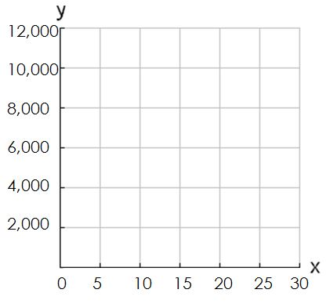

4. Josephine is 20 years old and wants to save $1 million for retirement in 50 years. Assume she invests in a savings account that earns at least the current rate of inflation (1.8%).

Recall the future-value formula:

5. Suppose Josephine does not want to begin saving for her retirement immediately. Fill in the following table to show the amount of money that Josephine must invest to retire 50 years from now with $1,000,000 based on the number of years that she waits to start saving.
Years of Waiting to Save | Principal Required
0
10
20
30
40
50

This means you have 40 years to save!

6. REFLECTION: Suppose Josephine believes in spending now and saving later. How could you use the table from Question 4 to convince her otherwise?

7. Blaine wants to have $1,000 in 10 years. The choices listed in the table below are the 3 different accounts in which he can invest.

- If Blaine plans on making no withdrawals or deposits for 10 years, rewrite the formula from Question 4 for present value and allow for any compounding period (n).

- Rewrite the present-value formulas for each account that Blaine is considering. Make sure that the formulas include compounding periods other than annual and incorporate the different rates.

a savings account earning 3% compounded quarterly | a checking account earning 1% compounded monthly | a money market account earning 4.5% compounded semiannually

9. REFLECTION: In which of the 3 accounts should Blaine invest? Why?

